|  |  |
| --- | --- |
| **Assessment task – Narrogin Senior High School** | |
| Year level | 8 |
| Learning area | Technologies |
| Subject | Digital Citizenship |
| Title of task | Network Diagram |
|  | |
| Description of task | Students are to place various electronic devices on a floor plan of a house. They will then draw a network diagram illustrating how these devices will be connected. The final part requires students to write a paragraph justifying their choices. |
| Type of assessment | Inquiry |
| Assessment strategy | Network Diagrams |
| **Content description** | |
| Content from the Western Australian Curriculum | **Designing**  Design, develop, evaluate and communicate alternative solutions, using appropriate technical terms and technology.  **Digital Implementation**  Design plans, using a sequence of steps, and represent them diagrammatically and in English, to solve a problem and to predict output for a given input to identify errors. |
|  | |
| Assessment conditions | 5-6 lessons in class. |
| Resources | Computers |

**Check List**

* **Labelled Floor Plan (Draft)**
* **Labelled Floor Plan (Final Copy)**
* **Network Diagram Draft**
* **Network Diagram (Final Copy) *Use symbols from Icon Library***
* **Paragraph – Final Copy**

**Task 1 - Part A - Network Diagrams**

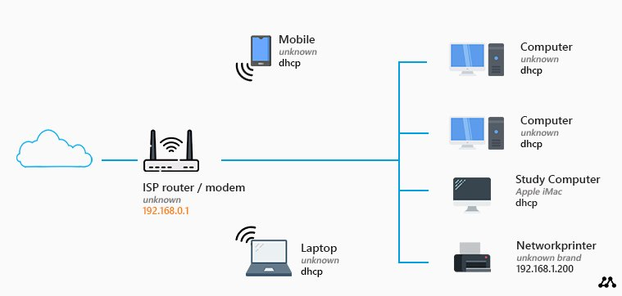A home network diagram is a schematic drawing of a home network layout. It helps you plan your home network and figuring the best layout for it.

This is the most basic home network diagram that you can have.

* We have a router with a built-in modem
* An access point that we got from our ISP (Internet Service Provider).

*These kinds of routers typically allow you to connect up to four devices using a network (UTP) cable.*

You might think, this is all I need. I can connect my computer(s) and printer with a network cable and wirelessly connect my mobile phones and/or laptops.

**But there is a big downside to this layout**.

You will have to place the router close to the point where the internet connection comes into your house.

Most of the time this is hidden in a utility room or garage. The wireless network range is limited, so you won’t have a good wireless network connection with this setup.

**You can only connect four wired devices**. A wired connection is the best connection that you can have. Ideally you want to connect your Smart TV, Game console, Printer, etc with a wired connection.

Your available options for connecting devices for this task is below along with their definitions.

|  |  |
| --- | --- |
| **Wired Access Point**  **C:\Users\ecoffey\AppData\Local\Temp\Rar$DRa0.403\30001_Device_access_point_default_256.png** | An Access Point (AP) is a device that can send and receive data. It receives an internet signal through an Ethernet cable connection to the router and converts it into a separate Wi-Fi network. |
| **Cloud**  **cloud computing icon on white background** | A vast network of remote servers |
| **Modem**  **C:\Users\ecoffey\AppData\Local\Temp\Rar$DRa0.694\30046_Device_modem_default_256.png** | A device connecting your home to your internet service provider (ISP) through a physical connection. The modem translates the data from your ISP into a format that your home network devices can use. |
| **Wireless Router**  **C:\Users\ecoffey\AppData\Local\Temp\Rar$DRa0.882\Cisco Icons November\30103_Device_wireless_router_3140\Png_256\30103_Device_wireless_router_3140_critical_256.png** | A router is a device that provides Wi-Fi and is typically connected to a modem. It sends information from the internet to personal devices like computers, phones, and tablets. These internet-connected devices in your home make up your Local Area Network (LAN). It allows for the connection of 5 wireless devices. Multiple Wireless Routers can be installed in a home |
| **Wireless Bridge**  **C:\Users\ecoffey\AppData\Local\Temp\Rar$DRa0.253\30102_Device_wireless_bridge_default_256.png** | The wireless bridge converts any wired network enabled device with available Ethernet port to latest wireless technology. |

Your task for this assignment is to place electronic devices around your house and create a network diagram which will allow these devices to connect.

The list of Electronic Devices is below for you. You must use **all** the required devices listed in your floor plan and network diagram, **plus** a minimum of 3 from the optional devices list.

*Tip: Read the information and definitions on the previous page to help you!*

|  |  |  |  |  |
| --- | --- | --- | --- | --- |
| **REQUIRED DEVICES** | | | | |
| Computer - Free computer icons | | 1 x Computer (Desktop) | IPad - Free technology icons | 1 x Tablet  (eg. iPad) |
| Laptop | | 1 x Laptop | Smart tv icon on transparent background 17785091 PNG | 1 x Smart TV |
| Cell phone - Free technology iconsCell phone - Free technology iconsCell phone - Free technology iconsCell phone - Free technology icons | | | | 4 x Mobile Phones |
| **OPTIONAL DEVICES (MINIMUM OF 3)** | | | | |
| Game console - Free entertainment icons | Gaming Consoles | | Smart tv icon on transparent background 17785091 PNG | Smart TV’s |
| Laptop | Laptops | | Printer - Free icons | Printer |
| Smart home - Free technology icons | Smart Home Device (eg. Google Home or Amazon Alexa) | | Media streaming device black glyph icon 2498797 Vector Art ... | TV Stream (eg. Amazon Firestick or Google Chrome Cast |
| Cell phone - Free technology icons | Mobile Phones | | IPad - Free technology icons | Tablets (iPad) |

Now you have chosen the devices you are going to use; the next step is to label where in the house you are going to put these devices.

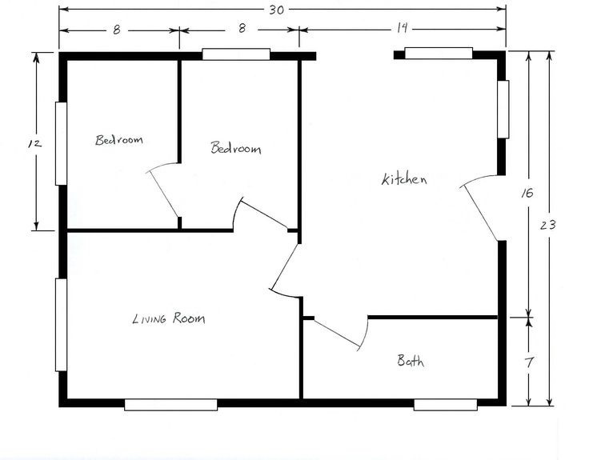Label the diagram on the following page with the location in your house you want to place all these devices. The next page is a draft copy. You will be given a final A3 Good Copy by your teacher.

**Part 2 – Network Diagram**

The next step is to create a Network Diagram. See the example network diagram below.

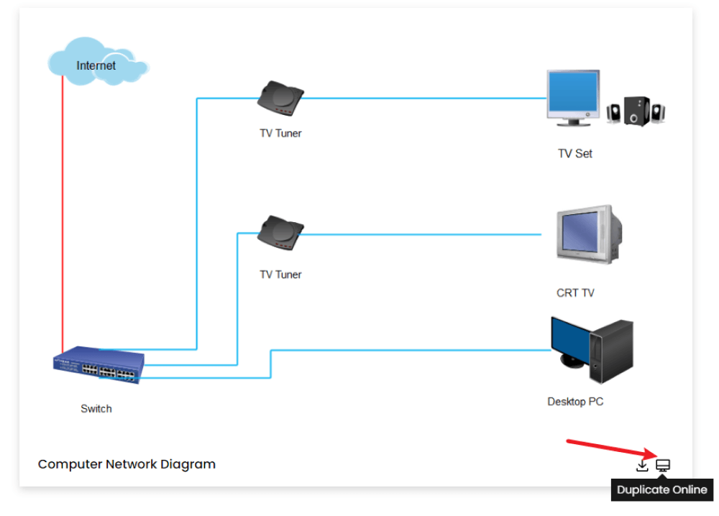

Create one of these to connect all the devices in your house. You have access to all the equipment listed on the front page to help you connect all your devices.

Draw a draft network Diagram in the box overleaf. Then create a final copy using the computer. A CISCO Icon Collection has been created for you with the correct symbols for you to use (on Connect).

**Task 2 – Part B – Paragraph**

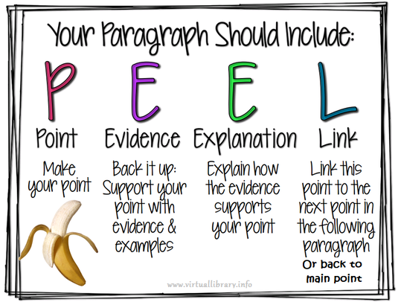You are required to write a paragraph explaining the choices that you made for your home network.

Use the draft paragraph below to help you create your paragraph. This can be in DOT Points. You will then write out your draft paragraph in full sentences on the following page.

Your final copy will need to be typed up.

**Draft Paragraph -** *Use dot points*

|  |
| --- |
| **POINT:** What are you going to be communicating. eg. Your home devices network |
|  |
| **EVIDENCE:** What equipment have you chosen to use. |
|  |
| **EXPLANATION:** Why have you chosen to use that equipment |
|  |
| **LINK:** Link your paragraph back to the main point. |
|  |

Turn the dot points above into a paragraph using full sentences below.

|  |  |
| --- | --- |
| **Marking key** | |
|  | Marks |
| **Inquiry Booklet** | Marks |
| Minimum of 3 extra electronic devices chosen | 1 |
| Draft floor plan is drawn | 1 |
| Draft network diagram is completed | 1 |
| Draft Paragraph is completed (boxes) | 1 |
| Draft Paragraph in full sentences is completed | 1 |
| **Subtotal** | **/5** |
| **Part 1 – Floor Plan (Good Copy)** | Marks |
| All chosen Electronic Devices are included in the floor plan, plan is very detailed, easy to read and understand. | 3 |
| Most chosen Electronic Devices are included in the floor plan, plan is easy to read and understand. Includes some detail. | 2 |
| Limited electronic devices are included in the floor plan, it is not easy to understand and includes limited detail. | 1 |
| **Subtotal** | **/3** |
| **Part 2 – Network Diagram (Good Copy)** | Marks |
| Includes cloud (or satellite in diagram) | 1 |
| Includes Modem in Diagram | 1 |
| Includes Wireless Router in Diagram | 1 |
| 4 Maximum Wired Devices Maximum | 1 |
| Wired Devices are shown with lines | 1 |
| 5 Maximum wireless devices are shown | 1 |
| Wireless devices are indicated with a symbol (wifi) | 1 |
| A Wireless bridge is included for any extra wired devices | 1 |
| Network is functional and uses CISCO Diagrams | 1 |
| **Subtotal** | **/9** |
| **Paragraph - Good Copy** | Marks |
| Paragraph accurately follows the PEEL structure, with coherent sentence structure and good spelling and grammar. It also references data from their survey | 5 |
| Paragraph mostly follows the PEEL structure, has mostly coherent sentences and mostly good spelling and grammar. Includes data that’s not referenced | 4 |
| Paragraph loosely follows the PEEL structure, has average coherent sentences and average spelling and grammar. Includes no data. | 3 |
| Paragraph makes minimal attempt at PEEL structure and follow spelling conventions. | 2 |
| Paragraph does not follow PEEL structure. No data. Poor spelling and Grammar | 1 |
| Subtotal | **/5** |
| Total | **/22** |